TinyOS Windows Installation for Agilla

Terminologies

$TOSROOT | $TOSROOT represents the location which tinyos is installed. It is always residing within the “cygwin/opt” directory. Thus, if you installed cygwin as “C:\tinyos\cygwin,” then TOS directory is “C:\tinyos\cygwin\opt\tinyos-1.x”
Alias | Representative or replacement. In the context of this installation, it means a replacement text. For example, instead of typing “cd /opt/tinyos-1.x” one can type “cd $TOSROOT” where $TOSROOT is an Alias of “/opt/tinyos-1.x”
HKLM | HKEY_LOCAL_MACHINE

Step ONE – Install TinyOS

Because both TinyOS and Agilla are ongoing works, the latest version from CVS is the best to work with as it ensure compatibility with the current version of CVS/TinyOS/Agilla. There are too many dependencies for one to figure out what version will work with what other version so CVS version is recommended.

- Install Cygwin (http://www.cygwin.com/setup.exe).
For CD installation: click on “Setup.exe” at CD main directory
  - Select “Install from Internet” in Choose Installation Type
For CD installation: Select “Install from Local Directory”
  - Root directory type “C:\tinyos\cygwin”
  - Make sure in Default Text File Type is “Unix / binary”
  - At Choose Download Site(s) choose “ftp://ftp.ntu.edu.tw” and any .jp one for redundancy.
CD: No such step
  - At Select Packages menu, click “view” to show full
  - Make sure “cvs, cvsutil” are installated by clicking on “Skip” to change to “1.11.17-1” (or whatever the current version is).
  - Likewise, repeat this step for all “gcc-*” packages, “openssh” packages, “perl-“ packages, “rpm-“ packages, and “vim-“ packages.
  - Click next a few times to get it to download and install. If you selected geographically closer mirrors like Taiwan and Japan, the installation should take approximately 10 min or less at approximately 100kb/s or higher download rate.
  - Run Cygwin once to setup the home directory
- Install Sun’s JDK 5.0. (JDK 5.09 as of this writing).
  - http://java.sun.com/javase/downloads/index.jsp
- Install Sun’s javax.comm package
  - Download http://www.maestra.tv/english/files/index.php?action=file&id=25
  - Unzip javacomm20-win32.zip
  - For CD installation: It has been pre-downloaded and extracted to javacomm20-win20 directory
  - Copy win32comm.dll to C:\Program Files\Java\jdk1.5.0_0x\jre\bin
  - Copy comm.jar to C:\Program Files\Java\jdk1.5.0_0x\jre\lib\ext
  - Copy javax.comm.properties to C:\Program Files\Java\jdk1.5.0_0x\jre\lib
- Install the following rpms (http://www.tinyos.net/dist-1.2.0/tools/windows/)
CD: pre-downloaded in directory “rpm package 1”
  - Download into a temporary folder (ex. \home\[your login name])
    - avarice-2.4-1.cygwin.i386.rpm
    - avr-binutils-2.15tinyos-3.cygwin.i386.rpm
    - avr-gcc-3.4.3-1.cygwin.i386.rpm
    - avr-insight-6.3-1.cygwin.i386.rpm
    - avr-libc-1.2.3-1.cygwin.i386.rpm
  - Install the packages with the following command:
    - Rpm –-ignoreos –ivh *.rpm
- Install the following rpms (separate step because they require additional option)
CD: pre-downloaded in directory “rpm package 2”
  - Download into a different temporary folder
    - msp430tools-binutils-2.16-20050607.cygwin.i386.rpm
    - msp430tools-base-0.1-20050607.cygwin.i386.rpm
    - msp430tools-gcc-3.2.3-20050607.cygwin.i386.rpm
    - msp430tools-libc-20050308cvs-20050608.cygwin.i386.rpm
  - Install with the following command:
    - Rpm --ignoreos --nodeps –ivh *.rpm
- Install the following rpms:
CD: pre-downloaded in directory “rpm package 3”
  - Download into a different temporary folder
    - make-3.80tinyos-1.cygwin.i386.rpm
    - nesc-1.2.7a-1.cygwin.i386.rpm
    - tinyos-tools-1.2.2-1.cygwin.i386.rpm
  - Install with the following command:
    - Rpm –ignoreos –ivh *.rpm
- Open cygwin, go to /opt, and download the TinyOS source files using cvs:
CD: The cvs files have been retrieved for you.
Simply copy directory “tinyos-1.x”from the CD to “C:\tinyos\cygwin\opt
  - $ cvs
-d:pserver:anonymous@tinyos.cvs.sourceforge.net:/
cvsroot/tinyos login
  - When prompted for password, press enter
  - $ cvs -z3
-d:pserver:anonymous@tinyos.cvs.sourceforge.net:/
cvsroot/tinyos co -P tinyos-1.x
- Download and install a text editor. I recommend Textpad but if you have something like Ultraedit install, it will work as well.
CD: Execute Textpad.exe and follow the instruction to install textpad.
- Download Makelocal, (http://mobilab.wustl.edu/projects/agilla/download/Makelocal) save it in $TOSROOT/tools/make/. This file contains custom local configuration.
CD: copy makelocal from pre-downloaded directory “Files to add” to C:/tinyos/cygwin/opt/tinyos-1.x/tools/make
  - Make sure that the “MIB510=” line is uncommented and has the value “/dev/ttyS*”, where * represents the COM port which is connected to the MIB510 board. Ex. ttyS0 = COM1, ttyS1=COM2, ttyS20=COM21

# Radio Frequencies: uncomment the line which has the frequency of your mote.
#Channel 0:
#PFLAGS += -DCC1K_DEF_FREQ=433002000
#Channel 2:
#PFLAGS += -DCC1K_DEF_FREQ=433616400
#Channel 4:
#PFLAGS += -DCC1K_DEF_FREQ=434107920
#Channel 6:
#PFLAGS += -DCC1K_DEF_FREQ=434845141

#PFLAGS += -DCC1K_DEF_PRESET=4

# Define the channel for the cc2420 chip. The default is 11.
# The valid range is 11-26
#PFLAGS += -DCC2420_DEF_CHANNEL=20
PFLAGS += -DCC2420_DEF_CHANNEL=15

# Define for your local group in hex (otherwise it is 0x7d).
DEFAULT_LOCAL_GROUP=0x07

# Choose programmer and port. If nothing uncommented, then assumes MIB500.
MIB510=/dev/ttyS0

# Uncomment out the following to enable Deluge
# TINYOS_NP = BNP

- Download washu.sh and tinyos.sh, and save them in /etc/profile.d/. These files contain various alias and environment variables. Most significantly are cdj (change directory to [tinyos]/tools/java/) and cdtos (change directory to [tinyos]), and cdapps (change directory to [tinyos]/apps/).
CD: copy washu.sh and tinyos.sh from pre-downloaded directory “Files to add” into C:\tinyos\cygwin\etc\profile.d
- Setup java's JNI library:
  - First make sure that in registry a few keys exist:
    - In Windows, click on “Start→Run”
    - Type in “regedit”
    - Find HKLM\SOFTWARE\JavaSoft\Java Development Kit
    - Make sure there is a String “CurrentVersion” with value “1.5”
    - Find HKLM\SOFTWARE\JavaSoft\Java Development Kit\1.5
    - Make sure there is a String “JavaHome” with value “[directory of your java installation]”
  - Download locate-jre (http://www.cse.wustl.edu/~liang/tinyos-install/windows/locate-jre) and save it in /usr/local/bin
  - Execute the following commands:
$ cdtos
$ cd tools/java/jni
$ make install
- Compile all of the Java Code
  - Use the following command:
$ cdj
$ make
- (Optional) Test if SerialForwarder works (make sure Java works):
  - Execute the command”
$ runsf_com1
  - You should see the following GUI:
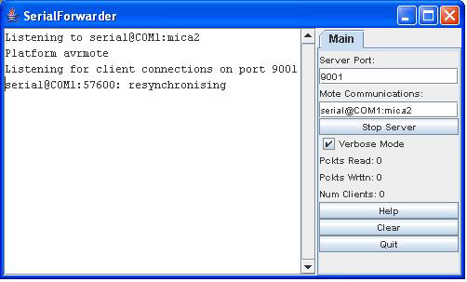
  - If the screen is different from the above (no “resynchronising” text), then double check step 3 and recompile java (step 12).
- (Optional) Test whether you can compile a TinyOS application:
  - Use the following commands:
$ cdapps
$ cd BlinkTask
$ make micaz
  - It should look similar to below with no error
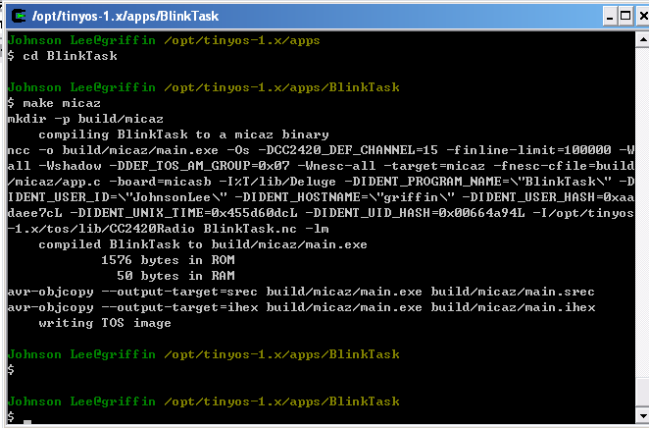
  - If you have the programming board and the motes connected, you can program BlinkTask onto the motes by using command “make micaz reinstall,0 mib510,com1” and seeing the motes blink red LED

Step TWO – Install and Setup Agilla

- Normally one would download Agilla via CVS but the previous CVS download included Agilla. However, in case you never need to update, it is included here:
CD: ignore this step
  - Download Agilla using the following command:
$cvs :pserver:anonymous@tinyos.cvs.sourceforge.net:/cvsroot/tinyos login

$cvs -z3 -d:pserver:anonymous@tinyos.cvs.sourceforge.net:/cvsroot/tinyos co \ -P tinyos-1.x/contrib/wustl
- Create a Makefile.Agilla file containing local settings within $TOSROOT/contrib/wustl/apps/Agilla. Simply copy the example file included with Agilla:
$ cd $TOSROOT/contrib/wustl/apps/Agilla
$ cp Example\ Makefile.Agilla Makefile.Agilla

See $TOSROOT/contrib/wustl/apps/Agilla/README for details on how to customize Makefile.Agilla.

- Open $TOSROOT/tos/system/Reset.h and add

|| defined (PLATFORM_MICAZ)

to the end of line 47 to allow remote reset of motes

- Install the NesC code onto every mote, including base station. One can use one of two ways to do this: the automated scripts or manual one-by-one. For automated script, use the following command:
  - $ cda
  - Edit $TOSROOT/contrib/wustl/apps/Agilla/
installer_mz.awk and change the programming board and COM port settings on line 20 to fit your setup (MiB510 board, Com1 for example).
  - Type in “riall_mz” and follow the on screen instruction
Alternatively,
- cd $TOSROOT/contrib/wustl/apps/Agilla/
make [platform] install,[id][programming board],[port]
Example, make micaz install,0 mib510,com1
- Agilla's AgentInjector is a Java program that allows users to inject mobile agents in to a wireless sensor network. It is located in $TOSROOT/contrib/wustl/tools/java/. The main class is edu.wustl.mobilab.agilla.AgentInjector.
  - Before compiling the AgentInjector, make sure:
    - Classpath contains: /opt/tinyos-1.x/contrib/wustl/tools/java
(If you have washu.sh installed in /etc/profile.d, it will run /opt/tinyos-1.x/contrib/wustl/tools/java/javapath which will ensure the above directory is in your classpath.)
    - You can view your classpath by typing $ echo $CLASSPATH
  - Then compile AgentInjector
$ cd $TOSROOT/contrib/wustl/tools/java/edu/
wustl/mobilab/agilla
$ cp Example\ Makefile.Agilla Makefile.Agilla
$ make

- Test the installation by launching the AgentInjector. Attach a mote to the PC and launch the AgentInjector using the appropriate COM port:
  - cd $TOSROOT/contrib/wustl/tools/java
java -Djava.security.policy=java.policy edu.wustl.mobilab.agilla.AgentInjector -comm COM2:115200 –col 1 &
NOTE:
Compared with the installation guide from Agilla website, the baud rate has been changed to 115200 instead of 57600. Experimental results show that only 115200 worked. In addition, “-col 1” has been added while “-d” has been removed. Since we use only a few motes, without “-col 1” there would be a long delay polling all the motes. The “-d” debug mode only adds to the problem by increase delay time.

  - Alternatively, one can modify the washu.sh file in /etc/profile.d to create an alias for running AgentInjector. There is an existing alias “ri” that is set to run AgentInjector.
  - You should see the following GUI:
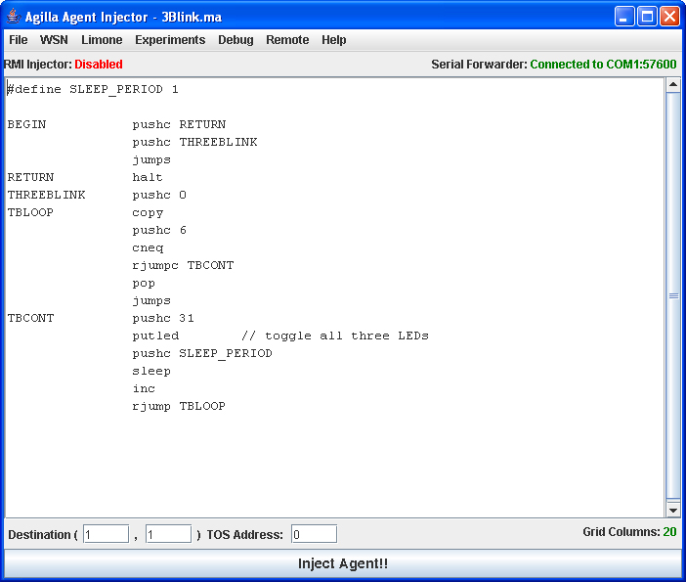
  - Type “Ctrl+R” to reset all the motes remotely. You should see all three LED blink for one second indicating they have been reset. If that does not work, there is a problem communicating from AgentInjector to the motes.
  - Type the address of the mote attached to the PC in the TOS Address box, and click on the “Inject Agent!!” button. The 3Blink agent will then be compiled and injected into the network. Watch the mote attached to the PC. It should blink its LEDs 3 times each time you inject this agent.

Debugging

Frequently one would have problem with Java AgentInjector.
- Isolate that the problem is Java by making sure the NesC codes are correct. Press the reset button on the motes and if all three LEDs lights up upon reset, the NesC codes have been correctly compiled and programmed.
- Check Window’s setup of the comm port you are using. Windows may default COM1 at a very low baud rate that Java reads and complies with. Go into control panel → system → Hardware tab → Device Manager button → Ports (COM & LPT) → Communication Port (COMx) → Port Settings. Make sure the “bits per second” is at least 57600 or higher.
- Tinker (tweak) with the alias “ri” that you use to run AgentInjector. Try removing all the parameters, then adding only “-col 3” (make sure at least three motes are on), then adding “-comm COM1:57600” or “-comm COM1:115200”

